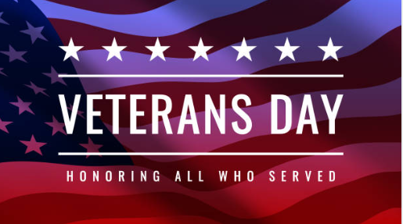

**The Kiwanis Club of Northside Atlanta**

**Has been invited to join**

**Second-Ponce de Leon Baptist Church**

**On Thursday, November 9th, 2023**

**For their Veteran’s Day Celebration**

**11:45 AM – 1:30 PM**

**Fellowship Hall**

**Please note the celebration begins at 11:45 AM and will take the place of our regularly scheduled meeting.**